DIS-AMK,C-Tlaoc-tlaloc figure. 7.5" tall without base. Ex. Melvin Dwork collection, Shelter Island , NY

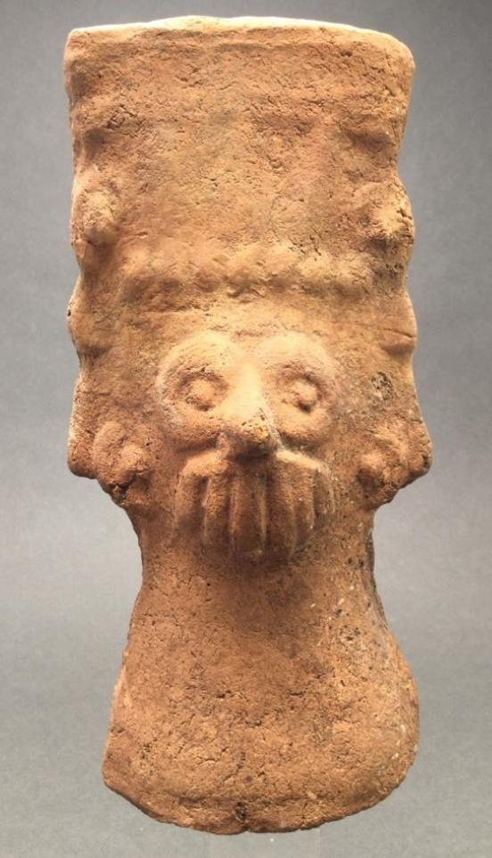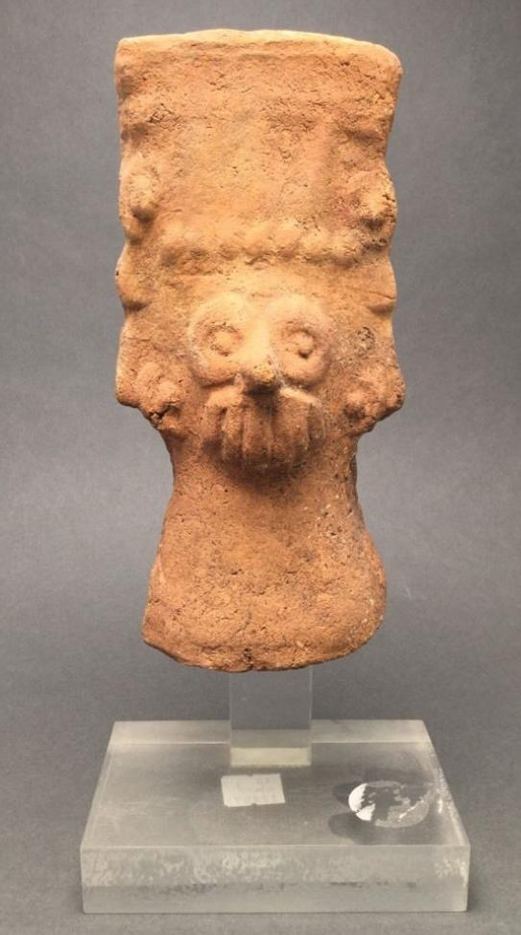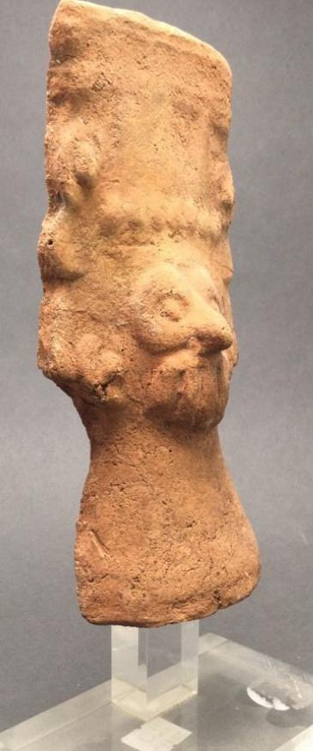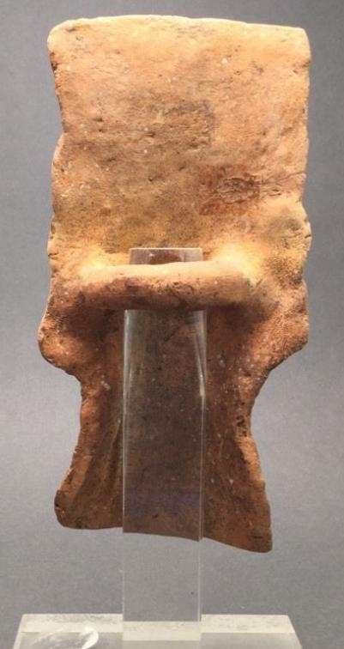

[Home](http://www.ebay.com/)   >   [My eBay](http://my.ebay.com/ws/eBayISAPI.dll?MyeBay)   >   Order details

# Order details

## Sales order

Sold by [bibliovendor](http://myworld.ebay.com/bibliovendor) ( [865](http://feedback.ebay.com/ws/eBayISAPI.dll?ViewFeedback&userid=bibliovendor) )

### Delivery package 1 of 1

Estimated delivery Saturday, Apr 9, 2016 - Wednesday, Apr 13, 2016

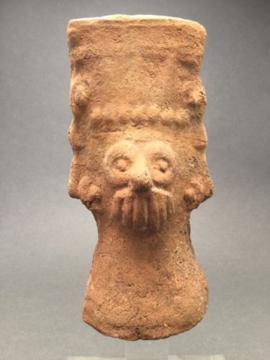

#### [precolumbian terracotta tlaloc figure ex. Melvin Dwork](http://www.ebay.com/itm/281976792152)

|  |  |
| --- | --- |
| Item price | $99.00 |
| Quantity | 1 |
| Item number | 281976792152 |
| Shipping service | USPS Priority Mail |

## Sales order

Sold by [jeanpier_360](http://myworld.ebay.com/jeanpier_360) ( [100](http://feedback.ebay.com/ws/eBayISAPI.dll?ViewFeedback&userid=jeanpier_360) )

### Delivery package 1 of 1

Estimated delivery Saturday, Apr 9, 2016

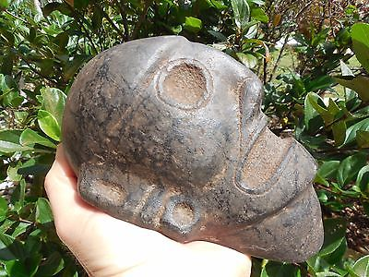

#### [TAINO PRE- COLUMBIAN BLACK STONE HEAD](http://www.ebay.com/itm/262353997406)

|  |  |
| --- | --- |
| Item price | $299.00 |
| Quantity | 1 |
| Item number | 262353997406 |
| Shipping service | USPS Priority Mail |

## Shipping address

Ralph J Coffman Jr

149 Atlantic Ave

Swampscott MA 01907-2427

United States

## Order total

|  |  |
| --- | --- |
| Subtotal | $398.00 |
| Shipping | $17.15 |

**Total**

$415.15

Order placed on

Saturday, Apr 2, 2016

Payment method

PayPal

Payment date

Saturday, Apr 2, 2016